
专题24 书面表达图表类

考点 | 十年考情（2015-2024） | 命题趋势
图表图画类  （10年8考） | 2024 年：1 篇  - 2024 全国甲卷（根据 “共享单车、高铁、新能源汽车” 图片，以 “Development of Transport in China” 为题写发言稿）  2022 年：1 篇  - 2022 全国乙卷（根据 “学生英语课外学习活动” 调查图表，以 “Learning English Beyond the Classroom” 为题投稿）  2020 年：1 篇  - 2020 北京卷（根据四幅 “居家学习自律调研” 图片，写英文稿件记述发现问题并解决的过程）  2019 年：1 篇  - 2019 北京卷（根据四幅 “劳动最光荣” 社会实践图片，写英文周记记述过程）  2018 年：1 篇  - 2018 北京卷（根据四幅 “接待外国学生体验中国茶文化” 图片，写英文周记记述全过程）  2017 年：1 篇  - 2017 北京卷（根据四幅 “制作‘感恩母校’毕业纪念视频” 图片，写英文周记记录过程）  2016 年：2 篇  - 2016 北京卷（根据四幅 “地球日系列活动” 图片，以 “Actions for a Greener Earth” 为题写英文稿件）  - 2016 上海卷（根据 “父母是否以子女为荣” 调研数据图表，写报告分析差异及原因） | 1. 题材聚焦现实生活与社会发展，强调实践与体验：以校园活动、社会热点、文化传承为主，如 “交通发展”“劳动实践”“茶文化体验”“环保行动” 等，贴近学生生活与时代主题，注重引导考生观察生活、参与实践。  2. 形式以图片叙事和数据图表为主，注重逻辑连贯性：图片类多要求按先后顺序记述事件过程（如 “活动准备 — 开展 — 成果”），数据图表类需描述数据差异并分析原因，均强调内容的条理性，通过时间连词（firstly、then、finally）或逻辑连接词（however、therefore）体现层次。  3. 考查重点偏向信息转化与观点表达，兼顾描述与评论：图片类需将画面信息转化为连贯的文字叙述，突出细节描写（如动作、场景、感受）；数据图表类需准确解读数据（比例、趋势），并结合实际进行合理评论（如分析现象原因、提出建议）。  4. 融入价值观引导与文化传播，体现育人导向：通过 “劳动教育”“环保行动”“文化体验” 等主题，引导考生树立正确的劳动观、环保意识和文化自信，强调在叙事中传递积极态度（如 “成就感”“自豪感”“责任感”）。


Writing 1
【2024全国甲卷】 英语课要求做课堂展示, 请你根据所给图片, 以Development of Transport in China为题写一篇发言稿。
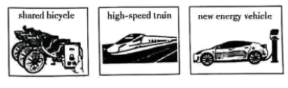
注意:
1. 词数 100 左右;
2. 题目和首句已为你写好。
Development of Transport in China
From the vehicle of horses to today's convenient transport, Chinese transport has an enormous development.
___________________________________________________________________________________________________________________________________________________________________________________________________________________________________________________________________________________________________________________________________________________________________________________________________________________________________________________________________________________________
【答案】Development of Transport in China
From the vehicle of horses to today’s convenient transport, Chinese transport has seen enormous development. Chinese transport has undergone remarkable transformations, giving the Chinese people access to different ways of travelling.
Firstly, shared bicycles have emerged as a symbol of urban mobility, offering an affordable and green alternative for short trips. Secondly, the introduction of high- speed trains has dramatically shortened travel times, making intercity travel faster and more comfortable. Lastly, the proliferation of new energy vehicles underscores China’s dedication to environmental sustainability, reducing reliance on fossil fuels. These developments illustrate China’s journey towards a modern and efficient transportation network that balances convenience with environmental responsibility.
In short, China’s transport system is embracing innovation and eco-friendliness.
【解析】
【导语】本篇书面表达属于应用文。要求考生根据所给图片，以Development of Transport in China为题写一篇发言稿。
【详解】1.词汇激活
提供：offer→provide
极大地：dramatically→tremendously
减少：reduce→decrease
总之：in short→in a nutshell
2.句式拓展
简单句变复合句
原句：Firstly, shared bicycles have emerged as a symbol of urban mobility, offering an affordable and green alternative for short trips.
拓展句：Firstly, shared bicycles, which offer an affordable and green alternative for short trips have emerged as a symbol of urban mobility.
【点睛】【高分句型1】Chinese transport has undergone remarkable transformations, giving the Chinese people access to different ways of travelling.(运用了现在分词作状语)
【高分句型2】These developments illustrate China’s journey towards a modern and efficient transportation network that balances convenience with environmental responsibility.(运用了that引导的定语从句)

Writing 2
【2022年全国乙卷】学校英文报正在开展以Learning English Beyond the Classroom为题的讨论。请使用图表中的调查结果写一篇短文投稿，内容包括：
1. 学习活动状况描述：
2. 简单评论;
3. 你的建议。
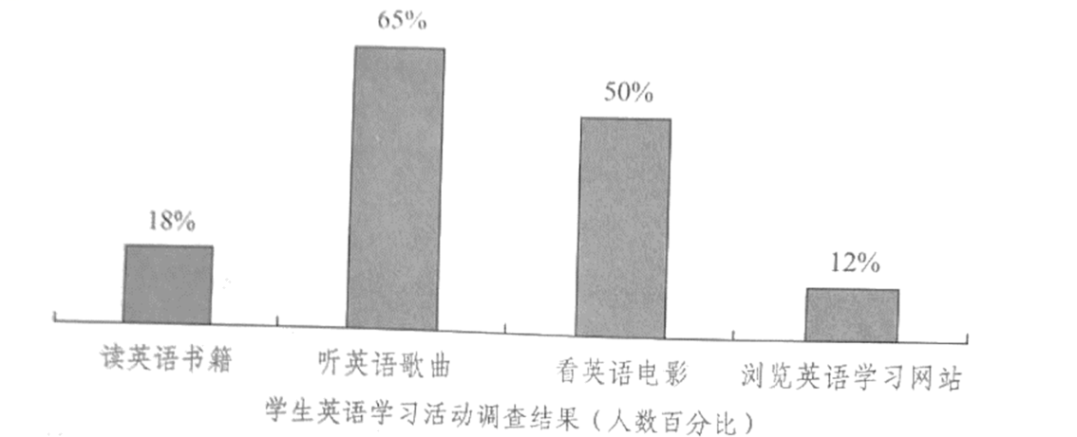
注意：
1. 词数100左右;
2. 短文的题目和首句已为你写好。
【答案】
Learning English Beyond the Classroom
Nowadays, with the growing popularity of smartphones and computers, an increasing number of students are choosing to learn English beyond the classroom in various ways.
It can easily be seen that the percentage of students who choose listening to English songs and watching English movies is respectively 65% and 50%. However, those choosing reading English books and visiting English learning websites only account for 18% and 12%.
As far as I’m concerned, it is a disturbing trend. For students, what benefits most to their study is reading English books. Because of their lack of self-discipline, they’re more easily addicted to chatting online or playing games. It’s urgent for students themselves to improve their self-discipline, and it’s also urgent for parents and teachers to strengthen the guidance.
【解析】
【分析】本篇书面表达属于说明文。要求考生请使用图表中的调查结果写一篇短文给学校英文报投稿。
【详解】1.词汇积累
选择：choose → select
提高：improve → strengthen
各种各样的：various → diverse
就我而言：as far as I’m concerned → from my perspective
2.句式拓展
简单句变复合句
原句：Nowadays, with the growing popularity of smartphones and computers, an increasing number of students are choosing to learn English beyond the Classroom in various ways.
拓展句：Nowadays, because smartphones and computers are becoming more and more popular, an increasing number of students are choosing to learn English beyond the Classroom in various ways.
【点睛】【高分句型1】It can easily be seen that the percentage of students who choose listening to English songs and watching English movies is respectively 65% and 50%. (运用了it作形式主语，that引导主语从句以及who引导的定语从句)
【高分句型2】It's urgent for students themselves to improve their self-discipline (运用了it作形式主语，to improve their self-discipline为真正的主语)

Writing 3
【2020年北京卷】假设你是红星中学高三（1）班班长李华。居家学习期间，你们班开展了一次以“自律”为主题的调研活动。请根据以下四幅图的先后顺序，写一篇英文稿件，给你们学校英文网站投稿，记述你在本次活动中发现问题并解决问题的过程。
注意：词数不少于60。
提示词：自律 self-discipline
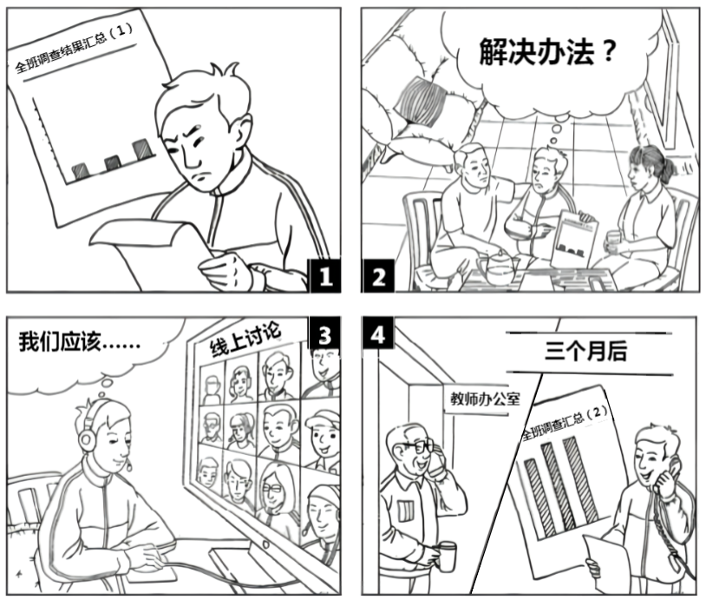
___________________________________________________________________________________________________________________________________________________________________________________________________________________________________________________________________________
【答案】One possible version:
While studying at home, I surveyed my class on “self-discipline”. The findings worried me a lot.
To solve the problem, I asked my parents for help, and they offered some practical advice. Then I held an online discussion with my classmates on how to well discipline ourselves. After that, we all knew better what to do.
Three months later, I did a second survey, which showed great improvements in self-discipline. I phoned my teacher about it, and we both felt very pleased.
【解析】
【分析】本篇书面表达属于应用文。这是一篇图画作文，要求考生按以下四幅图的先后顺序，就你开展“自律”调研活动中发现问题并解决问题的过程写一篇英文稿件，向学校英文网站投稿。
【详解】第一步：审题
体裁：应用文
时态：根据提示，时态应为一般过去时
人称：第一人称为主
结构：总分法
总分法指把主题句作为总说，把支持句作为分说，并以这种方式安排所写内容。
要求：1. 表明写作主题——“自律”
2. 根据图片描写事件过程：
第一幅图片描写自己对“自律”调研结果很担忧；
第二幅图片描写自己向父母求助解决方法/建议；
第三幅图片描写自己和同学们在网上讨论如何自律；
第四幅图片描写三个月后，大家自律能力有了很大提高，我和老师很高兴。
第二步:列提纲 （重点词组）
ask sb. for help；practical advice；an online discussion；do a second survey
第三步：连词成句
1. I asked my parents for help, and they offered some practical advice.
2. Then I held an online discussion with my classmates on how to well discipline ourselves.
3. I did a second survey, which showed great improvements in self-discipline.
(根据提示及关键词（组）进行遣词造句，注意主谓一致和时态问题。）
第四步：连句成篇（衔接词）
1.表文章结构顺序：First of all, Firstly/First, Secondly/Second… And then, Finally, In the end, At last, Last but not least
2.表并列补充关系：What is more, Besides, Moreover, Furthermore, In addition, As well as, not only…but (also), including, also
3.表转折对比关系：However, On the contrary, but, Although + clause (从句), In spite of + n/doing, On the one hand…,On the other hand… Some…,while others…,as for, so…that…
4.表因果关系：Because, As, So, Thus, Therefore, As a result
5表换一种方式表达：In other words, that is to say,
6.表进行举例说明：For example; For instance; such as + n/doing
7.表陈述事实：In fact, frankly speaking
8.表选择：either…or…，or
连句成文，注意使用恰当的连词进行句子之间的衔接与过渡，书写一定要规范清晰。
第五步：润色修改
【点睛】范文内容完整，结构严谨，要点全面，语言规范，语篇连贯，词数适当，上下文意思连贯，符合逻辑关系。作者在范文中使用了主从复合句，如which showed great improvements in self-discipline这句话中用了which引导的非限制性定语从句；使用了非常好的短语，如ask sb. for help，an online discussion，do a second survey等，为文章增色不少。全文中没有中国式英语的句式，显示了很高的驾驭英语的能力。另外，文章思路清晰、层次分明，上下句转换自然，为文章增色添彩。

Writing 4
【2019年北京卷】假设你是红星中学高三学生李华。你们班上周组织了一次以“劳动最光荣”为主题社会实践活动。请根据以下四幅图的先后顺序，写一篇英文周记，记述整个过程。
注意:词数不少于60。
提示词:西瓜watermelon
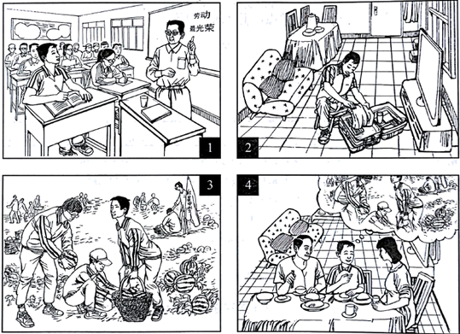
____________________________________________________________________________________________________________________________________________________________________________________________________________________________________________________________________________________【答案】
Last week I took part in a farmwork programme in the suburbs.
At the class meeting, our teacher told us about the programme with the theme “Working is most beautiful”. And he stressed the importance of working with our own hands. When I got home, I packed up my luggage for the trip.
On the farm, we helped pick watermelons. While working, I realised how hard it was to work in the fields under a hot sun.
When I came back home, I shared my experiences with my parents. And they were very proud of me.
【写作指导】
本文属于图画作文，要求根据图画内容写一篇英文周记。
【详解】假如你是红星中学高三学生李华，你们班上周组织了一次以“劳动最光荣”为主题的社会实践活动。要求根据以下四幅图的先后顺序，写一篇英文周记，记述整个过程。图画作文内容要点比较清晰，其中包括：老师宣布活动内容和意义，我为活动准备，在农场的劳动过程，介绍活动感受。这样有利于学生写作时发挥与扩展。全文可分成三部分，开头段概括活动，中间段描述图画，结尾段总结收获和意义。文章用第一人称来写，使用一般过去时。

Writing 5
【2018年北京卷】 假设你是红星中学高三学生李华，请根据以下四幅图的先后顺序，写一篇英文周记，记述你们上周接待外国学生，带领他们体验中国茶文化的全过程。
注意：词数不少于60。
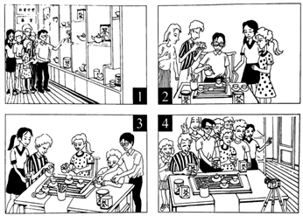
(请务必将作文写在答题卡指定区域内)
【答案】Last week, we took the foreign students in our school to experience the authentic tea culture, which turned out be to extremely rewarding.
On arriving at the tea house, the foreign students were impressed by the unique tea pots and tea cups. I gave them a vivid and informative introduction of tea culture, including its profound history, its rich variety, and the exquisite craftsmanship of making tea with their interest greatly sparked, I then began to teach them how to make tea.
In order to deliver a clear presentation, I slowly explained the traditional procedure of making tea in detail. Absorbed in every move of mine, the foreign students were once again amazed by this unique culture and they couldn’t help taking pictures from time to time.
Next came the moment when I asked them to have a try themselves. Washing the tea pots, adding tea leaves, and pouring water into the cups, they followed my instructions and were really immersed in charming tea culture. The tea house witnessed a really enjoyable time for all of us.
At the end of the activity, holding the tea bags in our hands, we took a picture to memorize the unforgettable day. It suddenly hit me that traditional culture like tea culture was of great charm and huge value. And I swelled with pride to spread our own culture to people all over the world.
【解析】本文为图片介绍类作文，这类作文是根据给出的一幅或几幅图画所提供的信息写短文。此类题的体裁较广泛，可以是记叙文、说明文，也可以是议论文。按照本文的要求可知，是写一篇记叙文。
1. 认真读图，把握中心。
根据提示可知，内容是带领外国学生体验中国茶文化的全过程，介绍了茶具，泡茶，沏茶，品茶的过程，所以这是这组图画所要表达的中心。
2. 初步构思，考虑用词、短语、句型和时态。
在把握了文章的中心后，应在内心构思一个基本的框架，并考虑使用恰当的词语、短语和句型，以充分地表达文章的内容。本文是讲述上周发生的事情，故时态要以过去时为主，人称是第一人称，尽可能地充分利用所学的短语或句型来表述具体的内容。这是体现自身能力的重要一环。
3. 连词成句，然后再连句成文。
运用适当的单词或短语正确表达各图的意思。然后再将各图的单个句子串连起来。
串连时，要注意使用适当的连接词语或过渡性语句，不至于让读者觉得文章中出现跳跃现象，更使上下文更为紧凑、自然。
4. 反复审核，修改错误。
一篇文章写好后，应进行检查，看短文中是否有错，如拼写、用词、时态、语态及表达方面的错误。
5. 宜详则详，该略则略。
对于一些细节方面的内容，如果是文章必不可少的，在写作过程中是不可将其忽略的。
如果是可有可无的细节，则可视具体情况进行增删。据此，我们在读图时一定要注意阅读各图中的一些细节内容，看其是否影响文章的内容。
亮点说明：
巧妙使用定语从句，提升了文章档次：Last week, we took the foreign students in our school to experience the authentic tea culture, which turned out be to extremely rewarding.
使用非谓语动词，使句子表达更简洁：
On arriving at the tea house…
I gave them a vivid and informative introduction of tea culture, including its profound history, its rich variety,
Absorbed in every move of mine, the foreign students were once again amazed by this unique culture
holding the tea bags in our hands, we took a picture to memorize the unforgettable day.
使用倒装句突出重点。
Next came the moment when I asked them to have a try themselves.
使用it做形式主语，使表达更地道。
It suddenly hit me that traditional culture like tea culture was of great charm and huge value.

Writing 6
【2017年北京卷】假设你是红星中学高三学生李华，请根据以下四幅图的先后顺序，写一篇英文周记，记录毕业前夕你们制作以＂感恩母校＂为主题的毕业纪念视频的全过程。
注意：词数不少于60。
提示词：视频 video
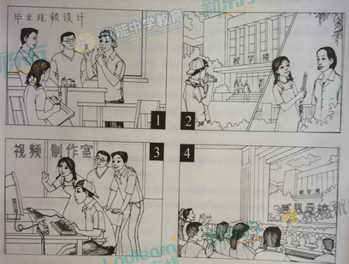
(请务必将作文写在答题卡指定区域内)
【参考范文】
Graduation finally came. My classmates and I decided to do something. After a heated discussion, we agreed
on making a video to record our experiences at school.
Material collecting took us a whole week, during which we interviewed our teachers and took pictures of
every aspect of school life. The editing part after that was tough. We debated over what to put into the video. Some compromises were unavoidable, but the video turned out perfect. Several days later, when the video was played on the graduation ceremony, it was well received. The students and teachers shared a great time. That surely gave us a great sense of achievement.
【名师点评】
本文属于看图说话类作文。首先要读懂图片隐含的信息，本文有四幅图，而且要求是按先后顺序，所以一定要注意顺序的问题；其次，根据图片隐含的信息把每幅图的主题找到，然后分别写出每幅图的主题句，也就是说把文章主体部分的大纲要列好，最后结合自己的看法，写出相应的总结和感受。写作的过程中一定要注意先后顺序，巧用连接词，巧妙衔接，合理安排。

Writing 7
【2016年北京卷】假设你是红星中学高三一班的学生李华。你班同学参加了学校的＂地球日＂系列活动。请按照以下四幅图的先后顺序，以＂Actions for a Greener Earth＂为题，给校刊＂英语角＂写一篇英文稿件，介绍活动的全过程。
注意：词数不少于60。
提示词：地球日Earth Day
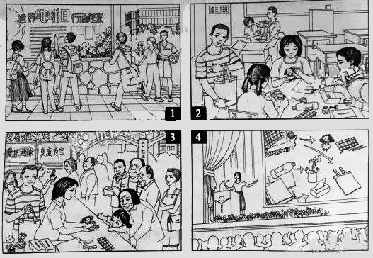
【答案】
Actions for a Greener Earth
A week before Earth Day, posters were put up around our school, calling upon us to join in the actions for a greener earth.
Our class came up with the idea to make better use of used materials. We brought to our classroom worn-out clothes, pieces of cardboard and empty plastic bottles and turned those into dolls, handbags, tissue boxes and small vases. That weekend, we went to a nearby neighborhood and gave them away to the people there. All were very happy with those unexpected gifts, especially little kids and elderly people. We did so well that we were invited to share our idea and experience with all the students of our school.
We are very proud of ourselves and believe we can do more for a better world.
【名师点评】
话题比较常规，整体难度适中。＂地球日＂系列活动属于保护环境的体裁内容，考生并不陌生。内容主要包括：公告栏了解活动、分工制作、变废为宝的宣传活动、主题讲座等。题目要求按照四幅图的先后顺序，以＂Actions for a Greener Earth＂为题，给校刊＂英语角＂写一篇英文稿件，介绍活动的全过程。词数不少于60词，参考词汇必须使用。使用一般过去时和第一人称进行写作。

Writing 8
【2016年上海卷】 假设你是中华中学学生姚平，最近参加了一项研究性学习调研，课题为＂父母是否以子女为荣＂。通过调研你校学生及其父母，结果发现双方对此问题的看法有差异（数据如图所示）。根据图表写一份报告，在报告中，你必须：
- 描述调研数据；
- 分析可能导致这一结果的原因。
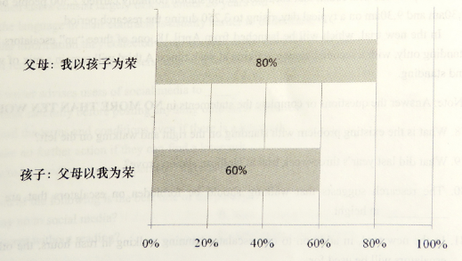
【答案】
（略）
【解析】
试题分析：本文属于图表作文。要求考生以姚平的身份写一则报告，通报＂父母是否以子女为荣＂的调研报告的内容。文章使用第三人称和一般现在时为主的时态。要点：1. 最近参加了一项研究性学习调研，课题为＂父母是否以子女为荣＂。通过调研你校学生及其父母，结果发现双方对此问题的看法有差异。2.百分之80的父母亲以孩子为荣；只有百分之60的孩子认为父母以我为荣。3.分析原因：父母亲把全部的精力都倾注在孩子身上，孩子的成功也证明自己的教育方法是正确的；而现在的孩子因为年龄较小，并没有很强的责任感，他们并没有感受到自己承担的义务和责任。建议在写作的时候添加适当的谚语，如Every coin has two sides.提升文采，以增加获得高分的可能性；穿插使用多种句式，让文章富有变化。同时要使用两到三个复合句，并适当使用连词。

